Supporting Information

Synthesis, Photophysical Properties and Antibacterial Activity of Cu(II) and Co(II) Porphyrins: Role of Ligand Modification
Belete B. Beyene* and Getaneh Achenef
Department of Chemistry, Bahir Dar University, Bahir Dar, Ethiopia, P.O.Box 79; E-mail: beleteb2002gmail.com

1. Materials and Methods

Chemicals and solvents
The chemicals and solvents used in this study include; copper chloride, cobalt acetate, and Silica gel, Hexane, acetone, Dichloromethane and Methanol.
Instruments
UV-Vis absorption spectra: The electronic absorption spectra of free porphyrin ligand and synthesized metalloporphyrins were measured using UV/VIS spectrophotometer (DRAWELL) in the 200 nm-800nm regions (Department of Chemistry, Bahir Dar University, Ethiopia)..
ESI-Mass Spectra: The electrospray ionization mass spectra of Fe-TPPCOOMe and Co-TPPCOOMe were measured by using Finnigan MATLCQ Mass Spectrometer (Institute of Chemistry, Academia Sinica Taiwan). Reference bacteria’s (S. aureus and S. pyogenes, E. coli and K. pneumoniae ) TLC plate,, Petri dish, agar plate.

2. Synthesis and Characterization

Synthesis and Purification of Co (II) and Cu (II) -5, 10, 15, 20–Tetrakis-(para-X phenyl) Porphyrin complexes
The complexes were synthesized by following way. The 5,10,15,20-tetrakis(para-X phenyl) porphyrin and the metal salt was taken in a 1:6 molar ratio. 30 mg of free base Porphyrin was dissolved in 10 mLof dichloromethane and the metal salt was dissolved in 5 mL of methanol. The solutions were mixed in a round bottom flask and heated for 24 h by hot plate at 40 ⁰c. The progresses of the reaction were checked by TLC (eluent dichloromethane, hexane and methanol). When the TLC were indicated the starting material was consumed, quench the reaction by added water, pour the solution into a separator funnel and washed with water (around 50 mL). Remove the excess metal with water and settled. The crude product was further purified by using column chromatography and the purity of the synthesized product was checked by using thin layer chromatography (TLC). The purity of the ligands was checked by TLC and ¹H NMR.

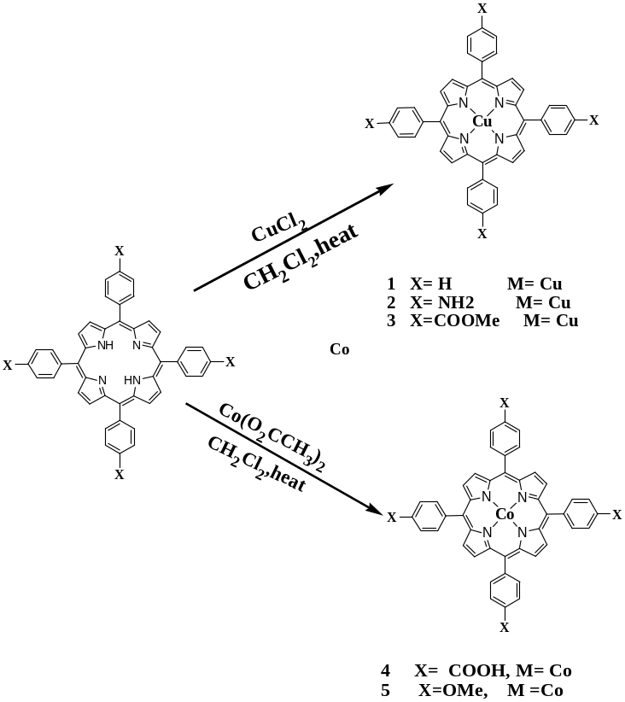
Figure SI-1. Synthesis of Co(II) and Cu(II)- 5, 10, 15, 20–Tetrakis-(para-X phenyl) Porphyrins.
Uv-Visible spectra
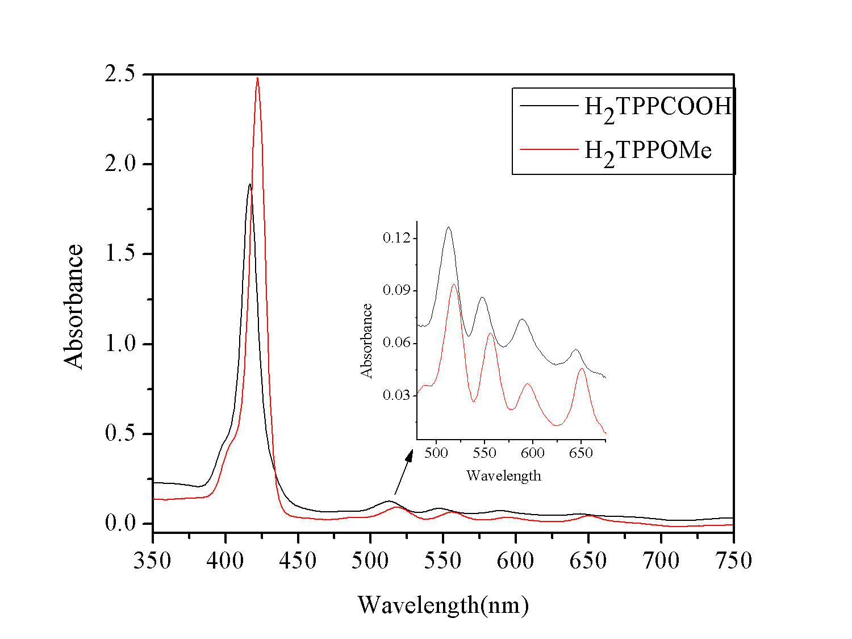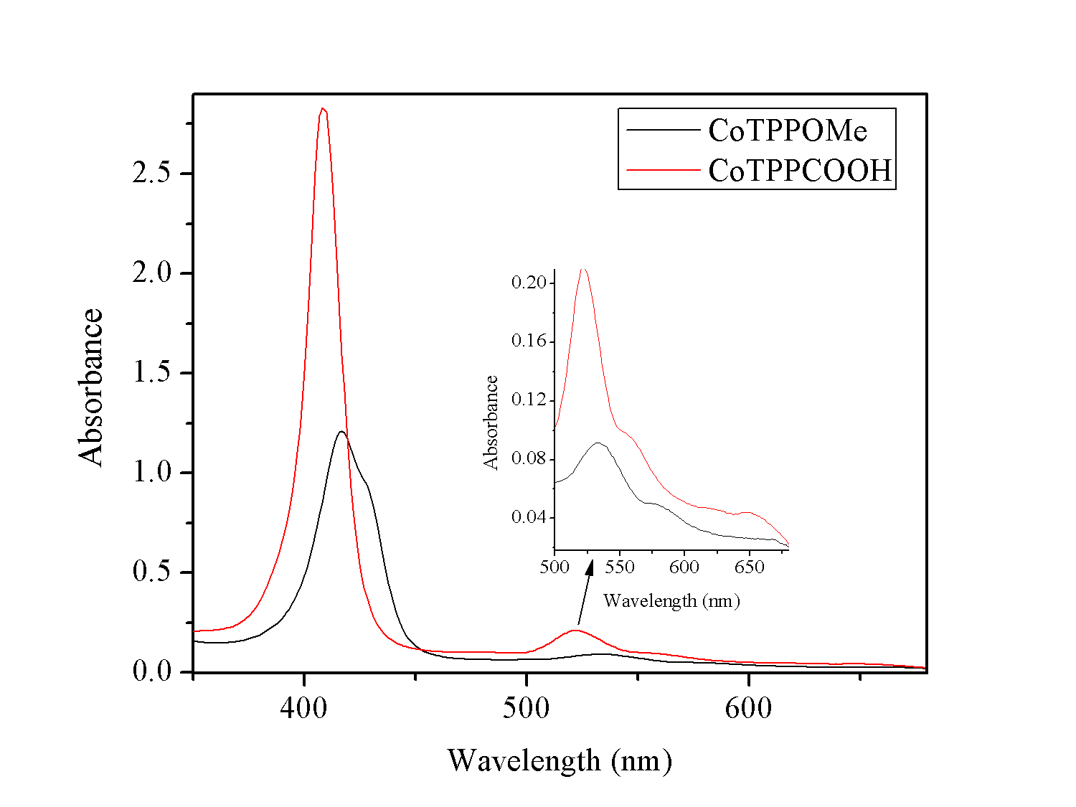
a) b)
Figure SI-2.The Uv-Vis spectra of a): H₂TPPCOOH and H₂TPPOMe; b) of CoTPPCOOH and CoTPPOMe

Table SI-1. The λ_{max} values of metalloporphyrins and free base porphyrins
Porphyrin | S band (nm) | Q band (nm)
Porphyrin | S band (nm) | Q₁ | Q₂ | Q₃ | Q₄
H₂TPP | 423 | 520 | 555 | 595 | 651
H₂TPPCOOMe | 419.5 | 515 | 550 | 591 | 645
H₂TPPNH₂ | 427 | 523 | 564 | 594 | 657
CuTPP | 416 | - | 539 | - | -
CuTPPCOOMe | 414 | - | 538 | - | -
CuTPPNH₂ | 425 | - | 545 | 584 | -
H₂TPPCOOH | 416 | 512 | 547 | 588 | 644
H₂TPPOMe | 422 | 518 | 556 | 595 | 650
CoTPPCOOH | 408 | - | 521 | - | -
CoTPPOMe | 417 | - | 433 | - | -

ESI-Ms SPECTRA
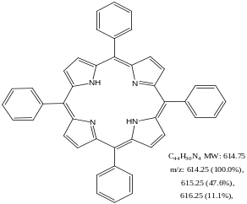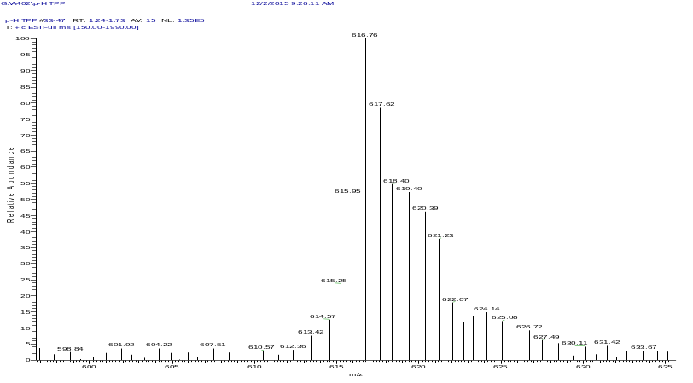
Figure SI-3. The mass spectrum of 5,10,15,20- tetrakis(4-phenyl)porphyrin(H₂TPP)

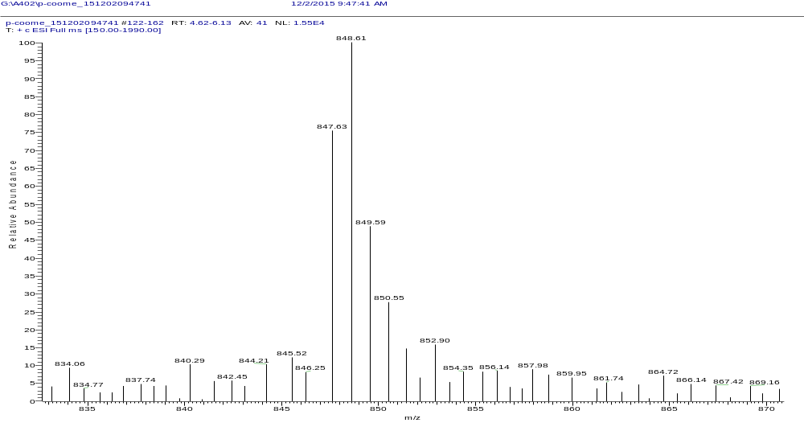
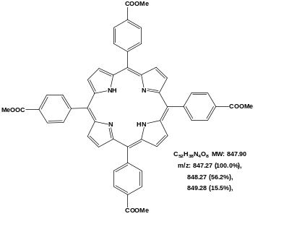

Figure SI-4. The mass spectrum of 5,10,15,20-tetrakis (4-(methoxycarbonyl)Phenyl)
Porphyrin,(H₂TPPCOOMe)
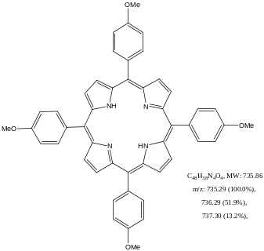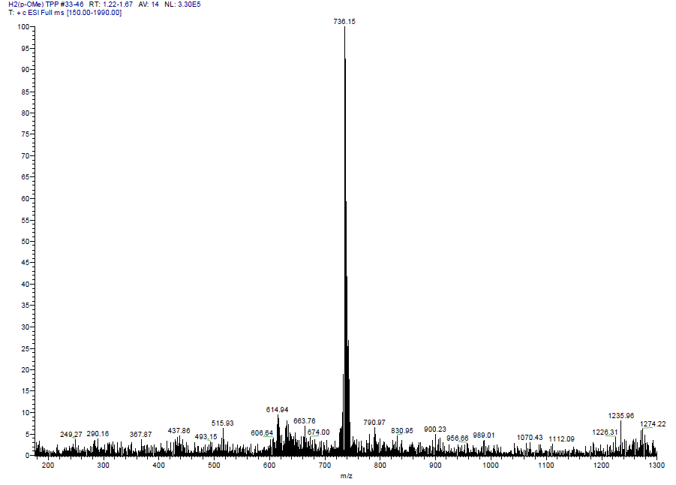
Figure SI-5. ESI-Ms of 5, 10, 15, 20-tetrakis (4-methoxyphenyl)porphyrin,(H₂TPPOMe)

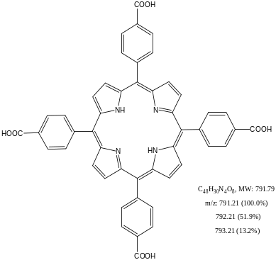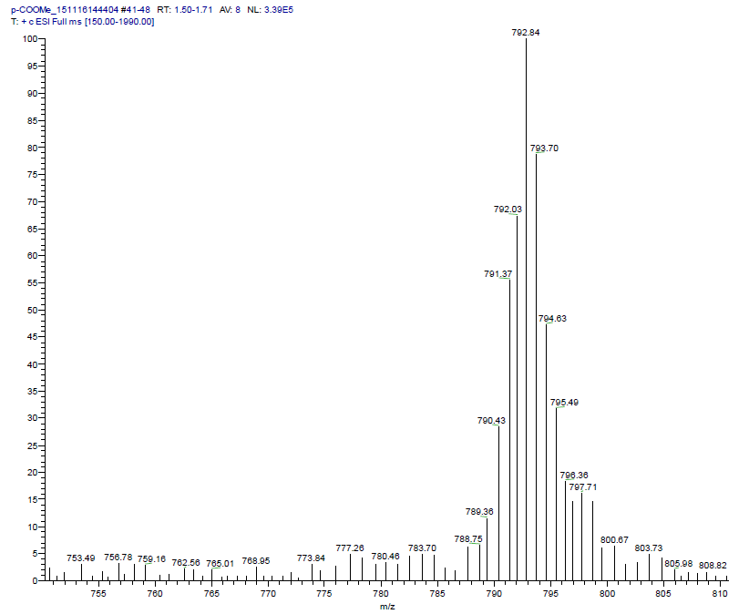
Figure SI-6 ESI-Ms spectrum of 5,10,15,20-tetrakis (4-carboxyphenyl)porphyrin,
(H₂TPPCOOH)
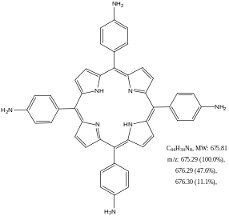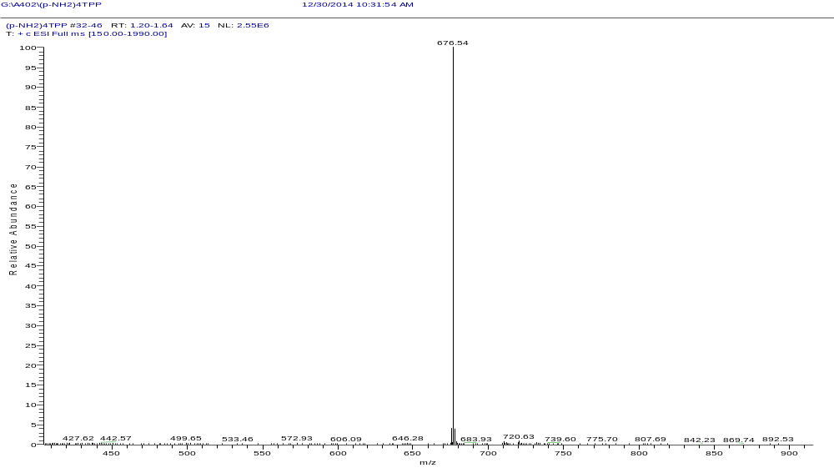
Figure SI-7. The mass spectrum of 5, 10,15,20-tetrakis (4-aminophenyl) porphyrin,
(H₂TPPNH₂)
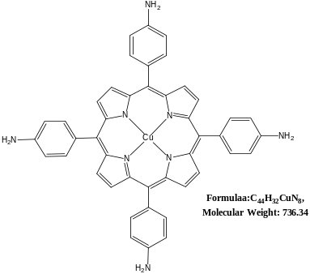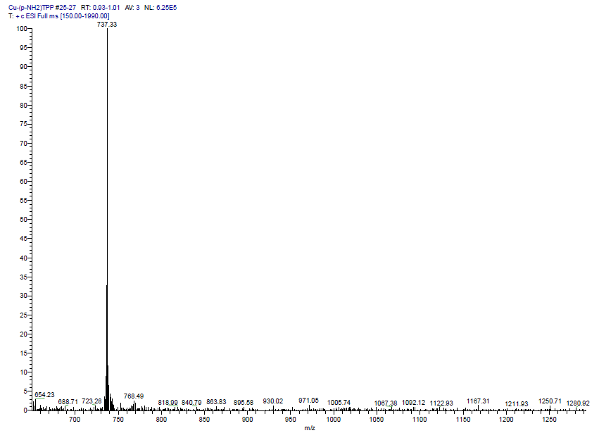
Figure SI-8. ESI-Ms spectrum of copper-5, 10, 15, 20-tetrakis(4-aminophenyl)
porphyrin(CuTPPNH₂)
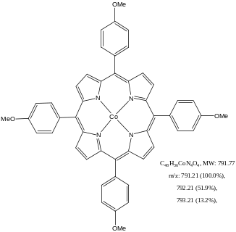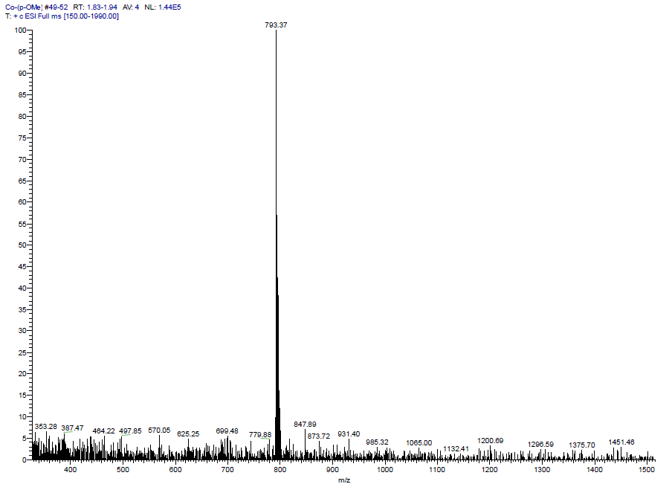
Figure SI-9 ESI-Ms of cobalt-5,10,15,20-tetrakis (4-methoxyphenyl)porphyrin (Co-TPPOMe)

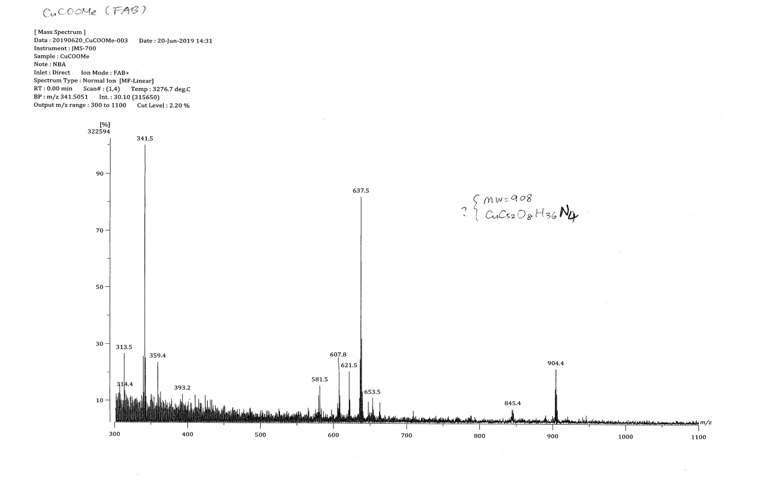
Figure SI-10 The mass spectrum of copper-5, 10, 15, 20-tetrakis (4-(methoxycarbonyl)Phenyl)
Porphyrin,(CuTPPCOOMe)

Table SI-2. The characteristic mass data for free base porphyrins and its metalloporphyrins.
Compounds | Empirical formula | Formula weight | MS (m/z)
H₂TPP | C₄₄H₃₀N₄ | 614.79 | 616.76
H₂TPPCOOMe | C₅₂H₃₈N4O₈ | 846.88 | 848.61
H₂TPPNH₂ | C₄₄H₃₄N₈ | 674.79 | 576.54
CuTPP | CuC₄₄H₃₀N₄ | 676.27 | -
CuTPPCOOMe | CuC₅₂H₃₈N₄O₈ | 908.43 | 904.4
CuTPPNH₂ | CuC₄₄H₃₄N₈ | 736.32 | 737.33
H₂TPPOMe | C₄₈H₃₈N₄O₄ | 734.84 | 736.15
H₂TPPCOOH | C₄₈H₃₀N₄O₈ | 790.77 | 792.84
CoTPPOMe | CoC₄₈H₃₈N₄O₄ | 791.75 | 793.37
CoTPPCOOH | CoC₄₈H₃₀N₄O₈ | 847.68
  848.91

¹H NMR spectra of free base porphyrins
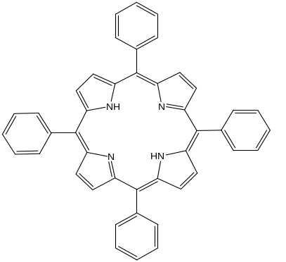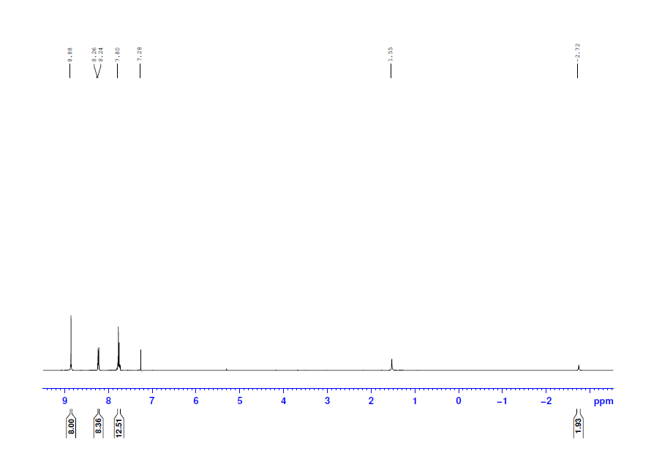
Figure SI-11 ¹H NMR spectra of 5,10,15,20-Tetrakis(phenyl)porphyrin (H₂TPP)

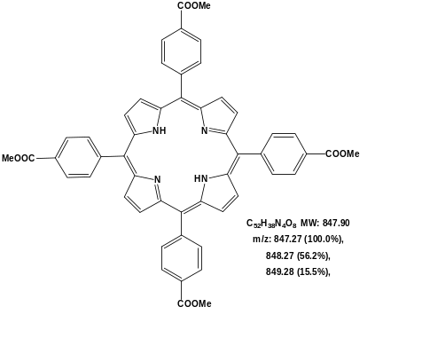
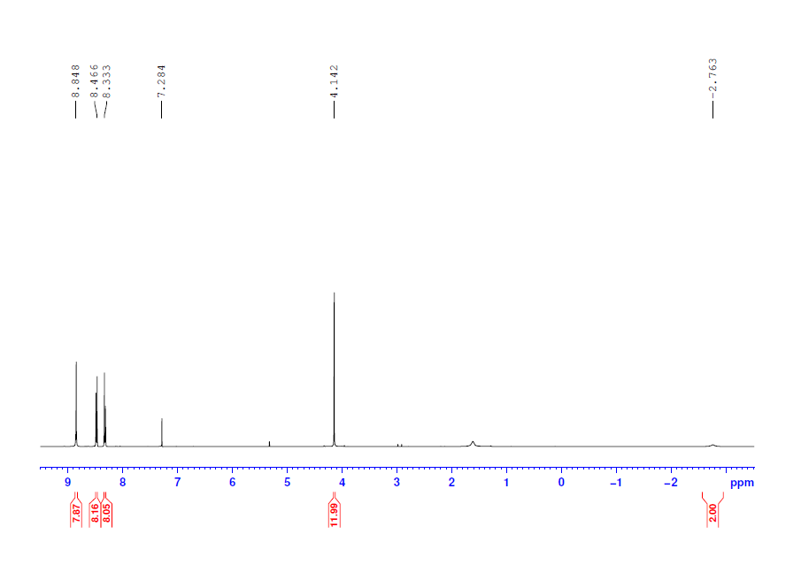
Figure SI-12 ¹H NMR spectra of 5,10,15,20-Tetrakis(4-(methoxycarbonyl)phenyl)porphyrin
(H₂TPPCOOMe)
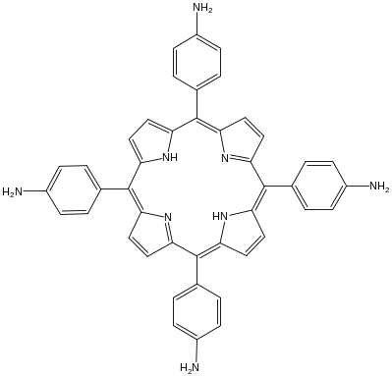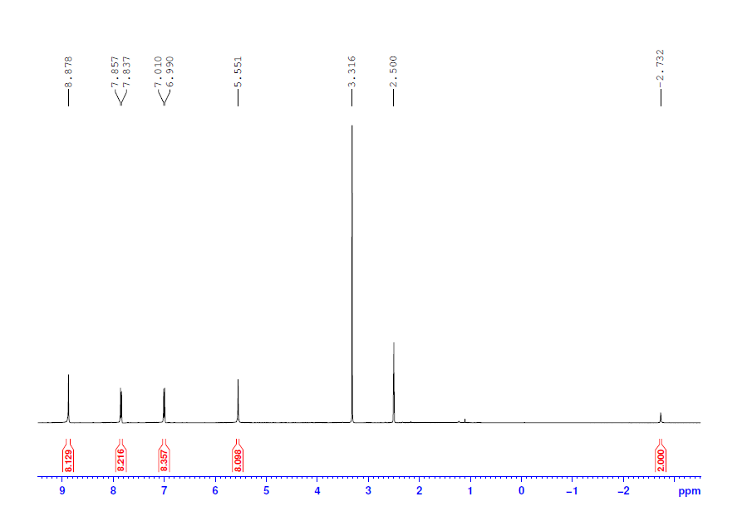
Figure SI-13 ¹H NMR spectra of 5,10,15,20-Tetrakis(4-aminophenyl)porphyrin (H₂TPPNH₂)

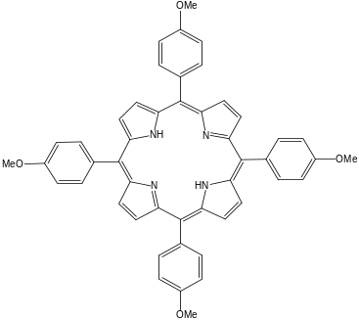
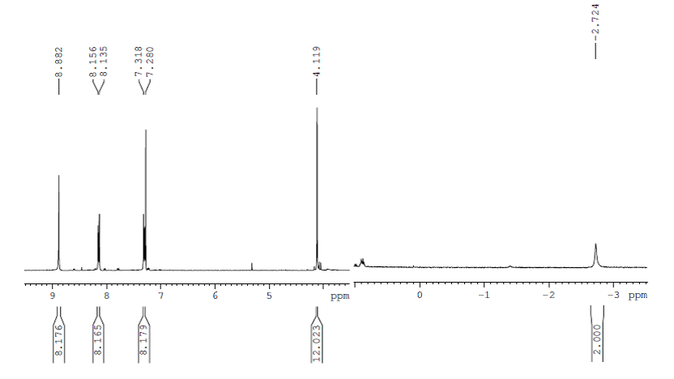
Figure SI-14 ¹H NMR spectra of 5, 10, 15, 20-Tetrakis(4-methoxyphenyl)porphyrin
(H₂TPPOMe)

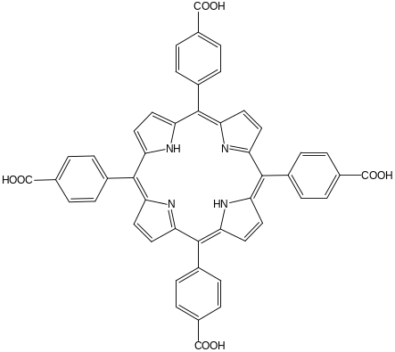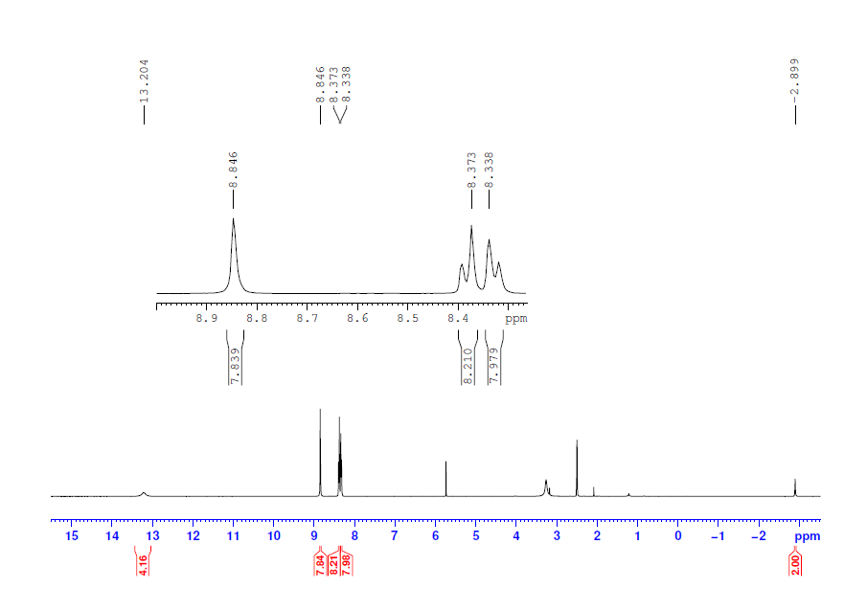
Figure SI-15 ¹H NMR spectra of 5, 10, 15, 20-Tetrakis(4-carboxyphenyl)porphyrin
(H₂TPPCOOH)

Antibacterial Activity Testing
The metal salts, ligands and their metal complexes were evaluated for in vitro antibacterial activities against strains of the two Gram-negative bacterial strains such as E. coli and K. pneumonia; two Gram-positive bacterial strains such as S. aureus and S. pyrogens bacteria’s by disc diffusion method. In this method, activity of the test compounds was expressed by measuring the diameter of zone of inhibition. The plates were observed for zones of inhibition after 24 h, and incubation at 37 ⁰C. The diameters of the zone of inhibition produced by the complexes were compared with a standard antibiotic drug gentamycin. The bacteria’s used in this study were two Gram negative bacteria’s such as, Escherichia coli and Klebsiella pneumonia and two Gram positive bacteria’s such as staphylococcus aureus and streptococcus pyogenes. All the bacterial strains used in the experiment were received from microbiology laboratory technicians, Bahir Dar University.

Media preparation and sterilization
The Culture media (mueller Hinton) were prepared according to the manufacturer’s guideline (suspend 38 gm in 1L of distilled water). The mass of the culture medium was weighed and dissolved in distilled water. The mixture was stirred with a sterilized glass rod and tightly covered with an aluminum foil and then the culture medium was autoclaved for 15 min at 121 ºC. Next to that,the agar was allowed to cool in order to maintain the media in a molten stage. Petri dishes were dried in lower humidity by keeping them in a laminar flow hood. The freshly prepared and cooled Muller-Hinton agar was spread at the surface of petri dishes .

Inoculation of test Plates
A small volume, about 0.1 ml of the bacterial suspensions were inoculated onto the dried surface of Muller-Hinton agar plate and streaked(swabbed) by the sterile cotton swab over the entire sterile agar surface. This procedure was repeated by streaking two more times, rotating the plate approximately 60° each time to ensure an even distribution of inoculums and the rim of the agar was swabbed. The lid was left ajar for 3 to 15 minutes, to allow for any excess surface moisture to be absorbed before applying the samples on the respective well.

Sample Injection and Incubation
Anti-bactericidal activities of each reagents and synthesized complexes were evaluated by the dusic diffusion method. Agar were prepared by using a sterilized cork borer with 6 mm diameter, 4 mm deep and about 2.5 cm apart to minimize overlapping of zones. Then holes of 6 mm diameter were punched carefully using a sterile cork borer. The metal salts of each complex, DMSO, the ligands, and their metal complexes, .CuTPPCOOMe, CuTPPNH₂, CoTPPCOOH, CoTPPOMe were carefully injected to the respective disc in doublicate. The complex CuTPP was not done its antibacterial activity due to its insolubility in DMSO. The reference antibiotic agent disc (gentamicin) was dispensed via sterile pair of forceps onto the surface of the inoculated agar plate and pressed down to ensure complete contact with the agar surface. The complex, the ligand and the reference drug were allowed to diffuse for about 40 min before incubation and then the plates were incubated at 37ºC for 24 h. After 24 h incubation, the antibacterial activity was evaluated by measuring the diameter of inhibition zones in millimeter. The test was carried out in duplicate and the results were recorded as mean ± standard deviation.
Table SI-3. Antibacterial activity of CoTPPCOOH, metal salt, ligand, and reference antibiotic drug gentamicin
Compounds | Antibacterial activity ( mean IZ diameter(mm) ± SD)
Compounds | S. aureus | S. pyogenes | E. coli | K. pneumonia
CoTPPCOOH | 16.5 | 15 | 16 | 16
H₂TPPCOOH | 8.5 | 9 | 7.5 | 7.5
Co acetate | 6.5 | 7 | 6.5 | 6.5
DMSO | 0 | 0 | 0 | 0
Gentamicin | 25 | 27 | 26 | 25

Table SI-4. Antibacterial activity of CoTPPOMe at different concentration, metal salt, ligand, and reference antibiotic drug gentamicin in mm
Compounds | Antibacterial activiy ( mean IZ diameter(mm) ± SD)
Compounds | S. aureus | S. pyogenes | E. coli | K. pneumonia
CoTPPOMe | 12 | 14 | 10 | 12
H₂TPPOMe | 7. | 7.25 | 7 | 7
Co acetate | 6.5 | 8 | 7 | 7
DMSO | 0 | 0 | 0 | 0
Gentamicin | 27 | 25 | 26 | 25

Table SI-5. Antibacterial activity of CoTPPOMe at various concentration, metal salt, ligand, and reference antibiotic drug gentamicin
Compounds | Antibacterial activiy ( mean IZ diameter(mm) ± SD)
Compounds | S. aureus | S. pyogenes | E. coli | K. pneumonia
CuTPPCOOMe | 16 | 15 | 13 | 13.5
H₂TPPCOOMe | 8.25 | 8 | 7.5 | 7.5
CuCl₂. 2H₂O | 6.75 | 7 | 6.25 | 6.5
DMSO | 0 | 0 | 0 | 0
Gentamicin | 27 | 26 | 26.5 | 25.5

Table SI-6. Antibacterial activity of CuTPPNH₂, metal salt, ligand, and reference antibiotic drug gentamicin
Compounds | Antibacterial activiy ( mean IZ diameter(mm) ± SD)
Compounds | S. aureus | S. pyogenes | E. coli | K. pneumonia
CuTPPNH₂ | 13 | 13.5 | 12 | 12.5
H₂TPPNH₂ | 7.5 | 7.75 | 7 | 7
CuCl₂. 2H₂O | 7 | 7.5 | 7 | 6.75
DMSO | 0 | 0 | 0 | 0
Gentamicin | 25 | 28 | 26.5 | 25

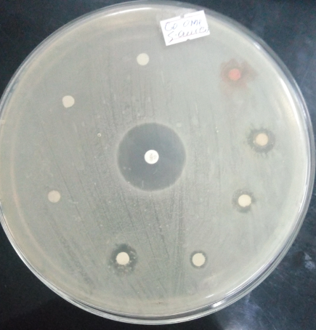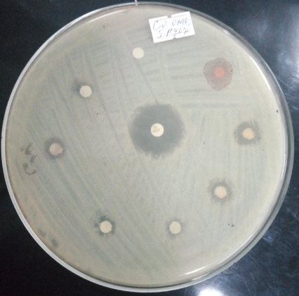
Figure SI-16. Gram positive Bacteria’s, S. aureusand S. pyogenesin CoTPPOMe molecule
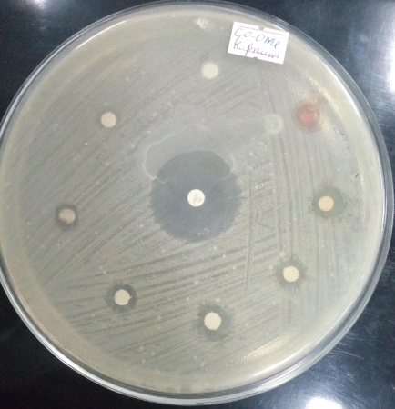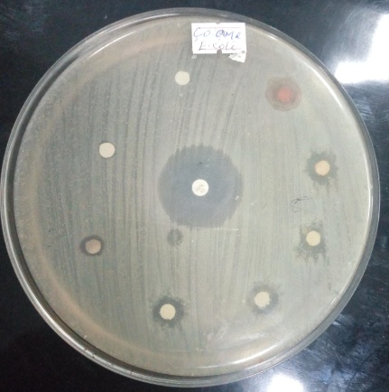
Figure SI-17. Gram negative Bacteria’s, E.coli and K. pneumoniain CoTPPOMe molecule

